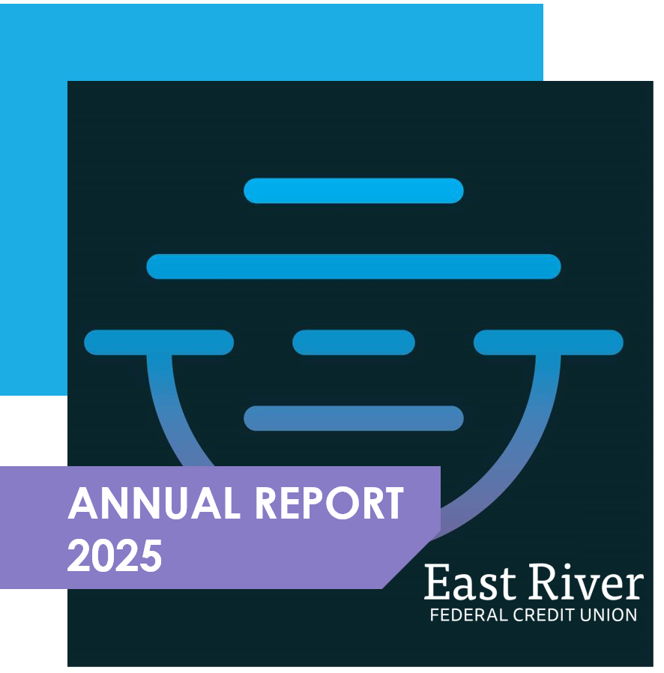

Supervisory Committee’s Message
The Supervisory Committee is responsible for safeguarding member assets by
ensuring the Credit Union is operating properly. As a volunteer committee, we have
broad oversight authority to hold the Credit Union's Board of Directors and senior
management accountable for fulfilling their responsibilities in the interests of the
members.

In conformance with regulations, the Supervisory Committee hired external
consultants to review compliance and have assessed the financial statements along with audit reports for the year ending on December 31, 2025. It is the pleasure of the Supervisory Committee to report to you that the affairs of East River Federal Credit Union during 2025 have been conducted in the most professional manner in accordance to prescribed standards and accounting practices, and were found to be current, accurate, complete and in balance.

The sound policies and practices of the Credit Union contributed to ending the year
with positive financial ratios within policy ranges. Continued efforts to monitor economic trends and adjust as needed provide for a positive impact on the Credit Union. We wish to commend the Board of Directors and staff on their service to our members.
Amy Dockendorf
Supervisory Committee Chair

REWARDS PAID TO OUR MEMBERS
FROM CASH BACK REWARDS
TO ATM REFUNDS & MUCH MORE
$165,789.58
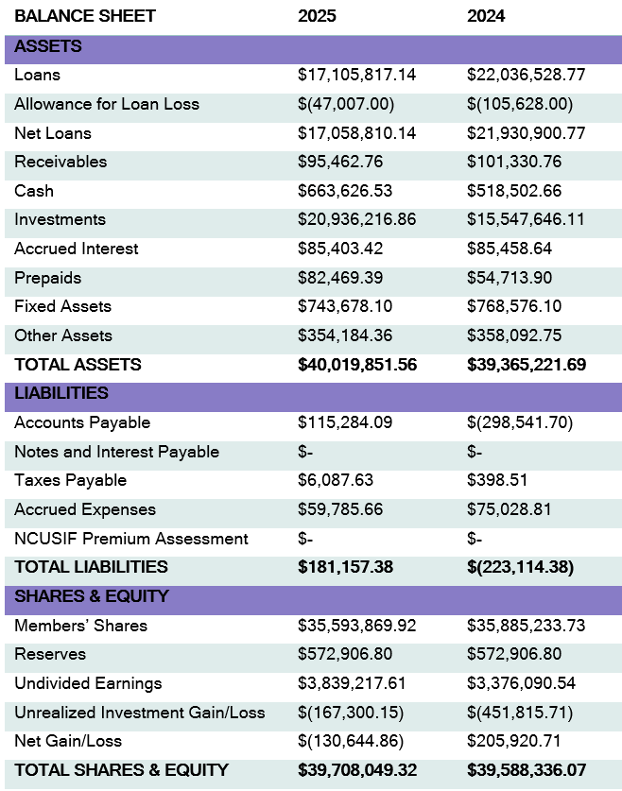

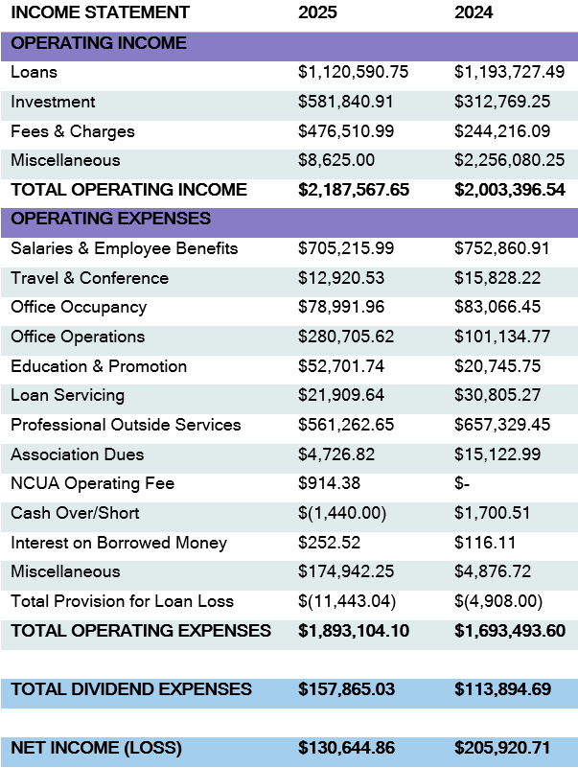

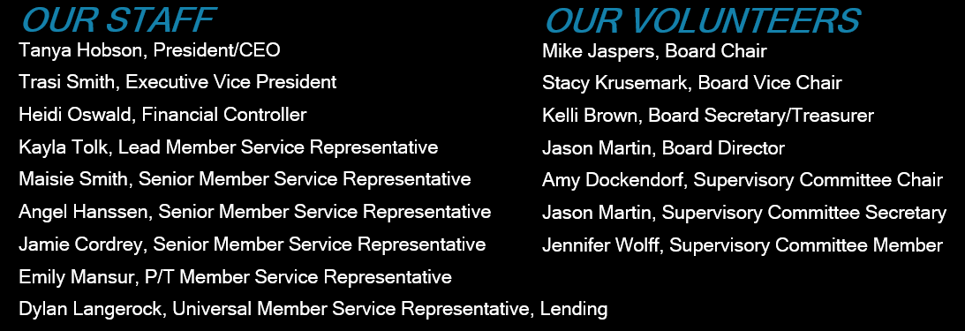

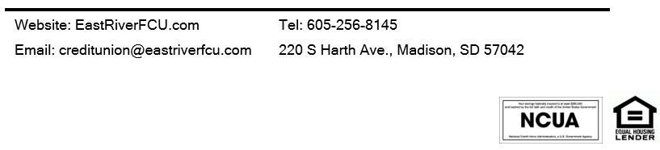

President/CEO’s Message
East River Federal Credit Union’s progress over the past year reflects a clear purpose: to become even more responsive to the needs of our members. With the foundation of our new core system in place, our focus has shifted from implementing technology to using better tools, information and capacity to create a stronger member experience.

That focus is central to our newest strategic direction — East River FCU Member Solutions. Rather than organizing our work around a list of products, we are organizing it around the real life needs those products are intended to solve. East River FCU Member Solutions brings our services together through six areas: Banking Solutions, Lending Solutions, Protection Solutions, Financial Guidance Solutions, Security Solutions and Community Solutions. The goal is to give members one trusted relationship that can support them through every stage of life.

The introduction of our new partnership with Dakota Financial Services is an important part of this approach. Through Protection Solutions, members will have access to a trusted insurance resource connected to East River FCU. This expands our ability to help members protect what they have worked hard to build while keeping the East River FCU relationship at the center of the experience. This new relationship is similar to our partnership with CU Mortgage Direct. We partnered with CU Mortgage Direct many years ago to ensure our members had a trusted full-service mortgage resource with many of our members having reaped the benefits of this relationship.

We also made meaningful progress in lending and digital service. We strengthened our lending capacity, focused on faster decisions when applications are complete, maintained competitive rates, and continued developing proactive opportunities that may help members save money. Digital tools such as account alerts, debit card controls and convenient preapproved offers will and are helping us make service more responsive, useful and secure.

Education remains a key part of being a trusted financial partner. Tanya’s Two Cents has provided timely, practical guidance about fraud, scams and everyday financial decisions. Within East River Member Solutions, this work complements our broader Security Solutions and Financial Guidance Solutions, connecting members with information and resources that help them move forward with greater confidence. Our reminder remains simple: Pause. Verify. Then Proceed.

East River FCU remains financially strong, well capitalized and committed to responsible growth. That strength allows us to invest thoughtfully in our people, technology, partnerships and communities. Our staff has continued to learn, adapt and align around our strategic goals while keeping members at the center of the work. We are grateful for their dedication and for the leadership of our Board of Directors and Supervisory Committee.

Most of all, we thank our members for your trust and continued participation in your credit union. East River FCU Member Solutions is more than a new marketing approach. It is our commitment to always begin with your needs, connect the pieces of your financial life and continue Building Success Stories together.

Sincerely,
Tanya Hobson
President/CEO

Chairman’s Message
The past year has been an important and exciting time of progress for East River Federal Credit Union. While 2025 brought with it the significant undertaking of converting to our new core processing system, it also marked the beginning of an important new chapter focused on becoming more efficient, more informed, and even better positioned to serve our members and community.

The conversion to our new core system was a major initiative that required tremendous effort, preparation, and commitment from the team. We are proud to say that the conversion was successfully completed and has provided the Credit Union with improved tools and enhanced capabilities to serve our membership. Additionally, the new system has given us access to better insights, reporting, and data analytics that allow our staff to better understand our members' needs, make more informed decisions, and perform their jobs more efficiently and effectively.

As we move through 2026, two of our primary areas of focus is supporting our local non-profit organizations, and financial education.

We recognize that strong communities are built by organizations and individuals who are willing to invest in one another, and we are proud to support the local non-profit organizations that work every day to make a difference. Through the introduction of our fee-free giving app (NetGiver), along with numerous sponsorships and donations ERFCU is committed to seeking meaningful ways to give back, strengthen local organizations, and make a positive impact beyond the walls of our Credit Union.

Another way we look to give back is by helping our members and community recognize and protect themselves from the growing number of financial scams and fraud attempts. With our new social media video series Tanya’s Two Cents, as well as our partnership with GreenPath financial counseling, debt management services, and financial education tools – ERFCU is making it part of our mission to educate and empower with practical information, resources, and awareness so our members and community can better recognize potential scams, protect their financial information, and make confident financial decisions.

None of this would be possible without the dedication of our management and staff. Their hard work throughout the core conversion and their continued commitment to finding better ways to serve our membership deserve our sincere appreciation. We also extend our gratitude to our members. Your continued loyalty, participation, and decision to make this Credit Union your financial institution are what make our cooperative possible.

The Board remains committed to providing the leadership and direction necessary to ensure the Credit Union remains financially strong, operationally sound, and focused on the needs of our membership. With the foundation we have strengthened over the past year, we believe we are well positioned to continue moving forward.

Thank you for your continued trust, support, and participation in your Credit Union. We are grateful for the opportunity to serve you, and we are excited for what the future holds.

Mike Jaspers
Board Chair

